Vet Skills Practice Quiz

- Heartworm Whipworm Roundworm Coccideia

- Dipydium Heartworm Whipworm Roundworm

- Coccideia Whipworm Roundworm Hookworm

- Taenia(Rodent) Dipylidium (Flea) Roundworm Whipworm

- Whipworm Hookworm Taenia (Rodent) Dipylidium (Flea)

- Heartworm Coccideia Roundworm Taenia(Rodent)

- Carmalt Forcep Bandage Scissors Mayo Scissors Backhaus Towel Clamp

- Spay Hook Kelley Forcep Carmalt Forcep Olsen Needle Holder

- Bandage Scissors Mayo Scissors Kelley Forcep Spay Hook

- Mayo Scissors Spay Hook Bandage Scissors Olsen Hagar Needle Holder

- Mayo Scissor Adison Tissue Forcep Bandage Scissors Olsen Hagar Needle Holder

- Mayo Scissor Spay Hook Bandage Scissors Backhaus Towel Clamp

- Bandage Scissors Spay Hook Adison Tissue Forcep Kelley Forcep

- Leur Lock Syringe Slip Tip Syringe TB Syringe Catheter Tip Syringe

- Kelley Forcep Mayo Scissor Adison Tissue Forcep Carmalt Forcep

- Curry Comb Dandy Brush Slicker Brush Shedding Blade

- Hoof Trimmer Plier Nail Clipper Gulitine Nail Clipper Hoof Knife

- Hoof Trimmer Hoof Nipper Hoof Knife Shedding Blade

- Ear Notcher Hoof Trimmer Hoof Nipper Hog Snare

- Slicker Brush Curry Comb Dandy Brush Shedding Blade

- Scoop/Tube Dehorner Balling Gun Hog Snare Elastrator

- Hog Snare Scoop/Tube Dehorner Ear Notcher Hoof Knife

- Hog Snare Emasculatome Hoof Knife Ear Notcher

- Emasculatome Ear Notcher Elastrator Hog Snare

- Hog Snare Elastrator Hoof Nipper Ear Notcher

- Yorkshire Terrier English Setter Chinese Shar Pei Basset Hound

- English Setter Basset Hound Yorkshire Terrier Great Pyrenese

- Great Pyrenese Basset Hound English Setter Yorkshire Terrier

- Yorkshire Terrier English Setter Great Pyrenese Basset Hound

- English Setter Chinese Shar Pei Yorkshire Terrier Great Pyrenese

- Persian Abyssinian Siamese Burmese

- Abyssinian Persian Burmese Abyssinian

- Burmese Persian Siamese Abyssinian

- Merino Dorset Landrace Southdown

- Dorset Hampshire Merino Suffolk

- Hampshire Merino Suffolk Southdown

- Dutch Polish Tan Satin

- Polish New Zealand Californian Mini Rex

- Netherland Dwarf Mini Rex Polish Holland Lop

- Abyssinian Guinea Pig Texel Guinea Pig Satin Guinea Pig American Guinea Pig

- Chinchilla Gerbil Degus Hamster

- Quarter Horse Clydesdale Morgan Arabian

- Morgan Tennessee Walker Quarter Horse Belgian

- Landrace Berkshire Hampshire Duroc

- Berkshire Duroc Landrace Hampshire

- Nubian Boar Alpine Saanens

- Saanens Toggenburg Oberhasli Angora

- Guernsey Jersey Ayrshire Shorthorn

- Hereford Simmental Charolais Limousin

- Limousin Charolais Simmental Angus

- What is the correct genus for Goats
  - Ovine
  - Caprine
  - Bovine
  - Porcine

- What is the correct genus for Cattle
  - Avian
  - Caprine
  - Bovine
  - Ovine

- Ovine is the correct genus for what animal
  - Goat
  - Cattle
  - Sheep
  - Horses

- A young female horse under three is called a
  - Filly
  - Colt
  - Mare
  - Foal

- A mature female pig that has had a litter is called a
  - Sow
  - Gilt
  - Ewe
  - Boar

- A mature female sheep is called a
  - Heifer
  - Doe
  - Sheep
  - Ewe

- A mature female goat is called a
  - Ewe
  - Heifer
  - Doe
  - Wether

- A pullet is a:
  - Mature female chicken
  - Mature male chicken
  - Young female chicken
  - Young male chicken

- Mature female cattle are called
  - Heifers
  - Cows
  - Steers
  - Calfs

- A mature intact male horse is called a
  - Stallion
  - Gelding
  - Stud
  - Steer

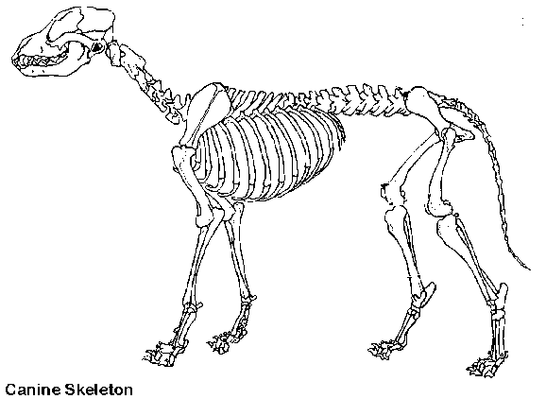
- What does the label A represent on the Canine skeleton?
  - Skull
B
  - Scapula
  - Pelvis
  - Vertebrae
A
C
- What does the label B represent on the Canine skeleton?
  - Tibia
  - Fibula
  - Femur
  - Humerus
- What does the label C represent on the Canine skeleton?
  - Radius
  - Ulna
  - Pelvis
  - Fibula

- What does the label D represent on the Canine skeleton?
  - Ribs
  - Vertebrae
  - Skull
  - Pelvis

- Simple stomachs are called
  - Monogastrics
  - Singular Stomachs
  - Ruminants
  - Gastritis

- In the ruminant which compartment of the stomach looks like a honeycomb
  - Abomasum
  - Reticulum
  - Cecum
  - Rumen

- Continuous regurgitation, chewing and swallowing is called
  - Digestion
  - Rumination
  - Eructation
  - Mastication
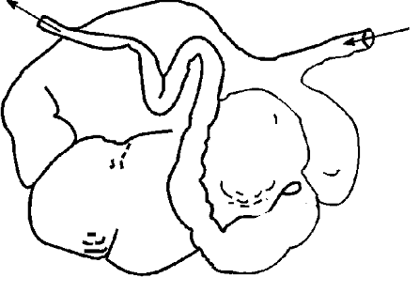
- Very muscular organ, used to grind food in birds is called the
  - Crop
A

  - Gizzard
  - Beak
  - Proventiculus

- What does the label A represent on the Ruminant digestive system?
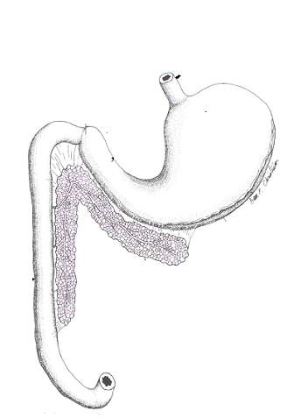
  - Abomasum
C
  - Omasum
  - Rumen
  - Reticulum

- What does the label C represent on the Monogastric digestive system?
  - Pancreas
  - Stomach
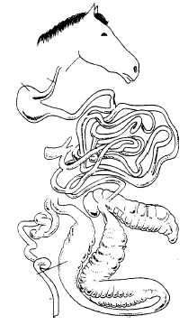
  - Large Intestine
  - Liver
D
- What does the label D represent on the
Hindgut fermenter digestive system?
  - Cecum
  - Large Intestine (Colon)
  - Stomach
  - Rumen

- Which nutrient contains the greatest amount of energy?
  - Water
  - Minerals
  - Fats
  - Vitamins

- This nutrient is essential because it is needed throughout life for growth and repair and is used for energy only if needed.
  - Carbohydrates
  - Protein
  - Fats
  - Minerals

- Which of the following is a fat-soluble vitamin?
  - Vitamin C
  - Vitamin A
  - Vitamin B6
  - Vitamin B12

- Which of the following is a water-soluble vitamin?
  - Vitamin E
  - Vitamin D
  - Vitamin A
  - Vitamin C

- Protein consists of strings of building blocks called?
  - Amino chains
  - Amino acids
  - Acetic acids
  - RNA

- Which of the following is a trace mineral?
  - Zinc
  - Sodium
  - Calcium
  - Phosphorus

- Which of the following is a macro mineral?
  - Sodium
  - Zinc
  - Copper
  - Selenium
- What does the label A represent on the sheep?
B
A
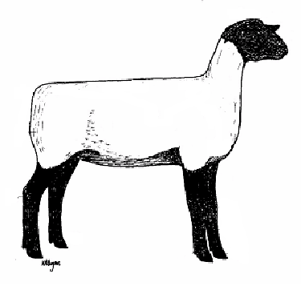
  - Loin
  - Hip
  - Wither
C
  - Neck

- What does the label B represent on the sheep?
  - Poll
  - Face
D
  - Muzzle
  - Neck

- What does the label C represent on the sheep?
  - Twist
  - Dock
  - Loin
  - Rump

- What does the label D represent on the sheep?
  - Cannon Bone
  - Pastern
  - Hoof
  - Hock

- What is the purpose of the marking harness?
  - Identifies which rams are ready for breeding
  - Provides proof of which ewes were bred and when
  - For cosmetic purposes
  - Identifies which ewes are ready for breeding

- What is the purpose of docking the tails of sheep?
  - Sheep do not have tails naturally.
  - To help keep the sheep clean from manure
  - For appearance only
  - In order to show sheep at shows

- In the universal ear notching system of hogs, what does the right ear number represent?
  - Individual Pig number
  - The Sows number
  - Litter number
  - Number of piglets in the litter

- Name the type of hog operation that raises hogs from birth to slaughter weight
  - Breeding Stock
  - Farrowing Operations
  - Finishing Operations
  - Farrow to Finish

- Name the type of hog operation that purchases weaned piglets and raises them to market weight
  - Seedstock
  - Farrowing Operations
  - Finishing Operations
  - Farrow to Finish

Sassy is an 18-month-old (1 ½ years) female horse who measures 10 hands. Please answer the following three questions regarding Sassy.

- How many inches is Sassy?
  - 14 inches
  - 24 inches
  - 40 inches
  - 42 inches

- At this size what type of horse would Sassy be considered
  - Horse
  - Short Horse
  - Pony
  - Draft

- According to her age and sex Sassy would be called a?
  - Filly
  - Mare
  - Stallion
  - Gelding

- Measurement term used in horses from ground to withers.
  - Foot
  - Hand
  - Yard
  - Inches
- A pony can not be greater than:
  - 14 hands
  - 14.2 hands
  - 12 hands
  - 10 hands
- The term for away from the midline is
  - medial
  - lateral
  - proximal
  - distal
- The term that refers to the back is
  - ventral
  - dorsal
  - cranial
  - caudal
- The term that means toward the head is
  - ventral
  - dorsal
  - cranial
  - caudal
- The organism that causes heartworm is:
  - Dirofilaria immitis
  - Taenia pisiformis
  - Giardia
  - Protozoa
- The most common endoparasite of puppies and kittens is:
  - flea
  - roundworm
  - mite
  - protozoa
- What parasite transmits Lyme disease?
  - Dirofilaria immitis
  - Heartworm
  - Lice
  - Tick
- Which of the following is not a mite?
  - Otodectes
  - Cheyletiella
  - Demodex
  - Ixodes
- What is the intermediate host of Taenia?
  - Mice
  - Flea
  - Ticks
  - Mite

